**Q2**: Display typelD, name of all types having name beginning with a ‘D’ or an ‘S’ as in the following figure.

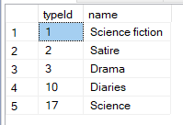

**Q3:** Write a query to select studentld, name, surname, gender, class, point of all female students whose class name beginning with ‘12’ and who have at least 500 points; display the results by ascending order of class, then by ascending order of srtudentlD for students of the same class as follows:

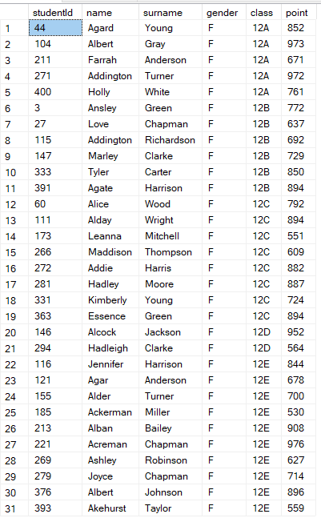

**Q4:** Write a query to display borrowld, takenDate, bookld, bookName, typeld, typeName of all borrows in March 2017 (considering the takenDate) of all books of the type ‘Diaries’ or ‘Art'; display the results in descending order of typeName, then by ascending order of borrowld for borrows of books of the same typeName as follows:

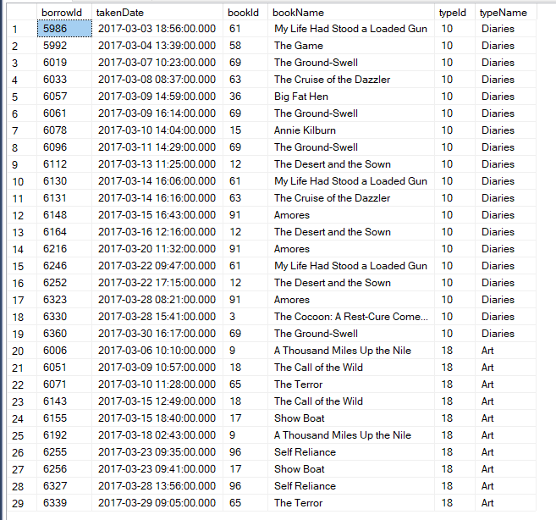

**Q5:** Write a query to display authorld, authorName, authorsurname, NumberOfBooks, NumberOfBorrows corresponding to each author where NumberOfBooks is the number of distinct books written by each author, and NumberOfBorrows is the number of borrows in which a book of the corresponding author was borrowed as follows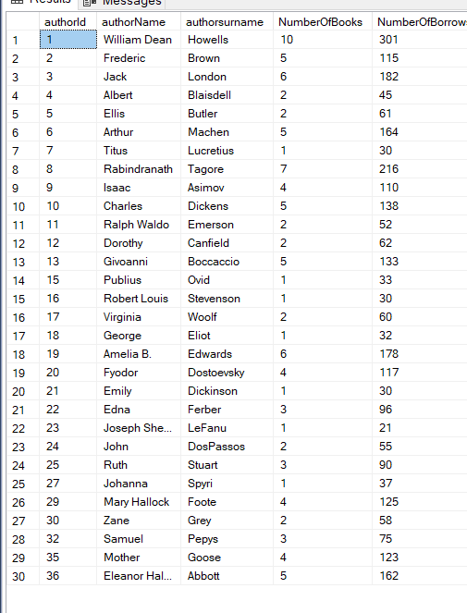

**Q6:** Write a query to display typeld, typeName, NumberOfBooks corresponding to the types having the highest number of distinct books (NumberOfBooks) as follows:



**Q9:** Create a trigger named Tr2 for the insert statement on table books so that when we insert one or more rows into the table books, the system will display the bookld, bookName, authorld, authorName, authorsurname, typeld, typeName corresponding to the inserted books.

for example, when we execute the following statement, the results should be as in the following figure:

insert into books(bookld, name, pagecount, point,authorId,typeld) values  
(500,'book 1', 250, 10, 1, 1),

(501,'book 2’,200,15,2,3)

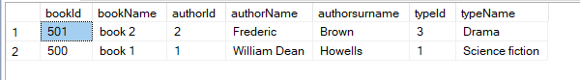

**Q10:** Write a query to update the class as ‘9A’ for all students belonging to the classes having the name beginning with ’9’ and having more than 900 points.

After updating the corresponding table, if we run the following statement, the result should be as in the following figure:

